Ukraine Improvised Explosive Devices Text Visualization Poster

Valérie Lavigne

# Introduction

This project will allow the exploration of over 600 Improvised Explosive Devices incidents in Ukraine over the past 2 years for the purpose of highlighting and better understanding the temporal, geographical and political patterns from a dataset produced by the NATO Counter-IED Center of Excellence (NATO C-IED COE). We will consider additional census data and election statistics to uncover potential regional patterns, as well as publicly available data about the existing conflict in Eastern Ukraine. We intend to employ interactive visualization to generate better insights about the Ukraine IED situation. Figures 1 below show current static visualization employed by the C-IED COE to visualize this data. This is a NATO Unclassified IED events spreadsheet from the NATO C-IED COE. It contains 665 events, with 15 in 2001-2013, about 230 in 2014 and the rest in 2015. It contains the following column headers (text field are in **bold**): Date, **Type**, KIA (Killed in Action), WIA (Wounded in Action), **City**, **Region**, **Country**, **Details**, **Group**, **Remarks**.

*Figure 1: Current visualization of the textual information and statistical data*

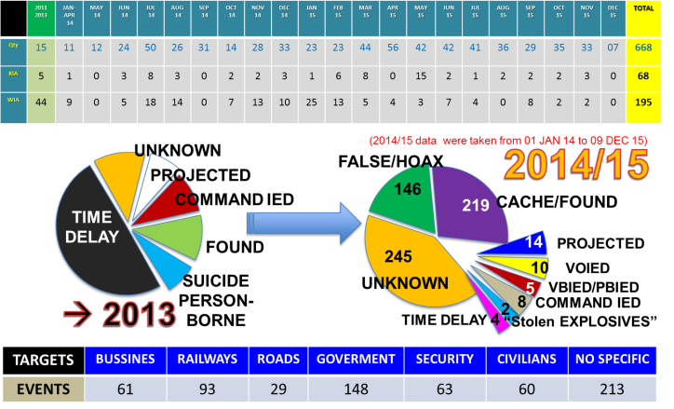

# Text Visualization 1: Split Bubbles

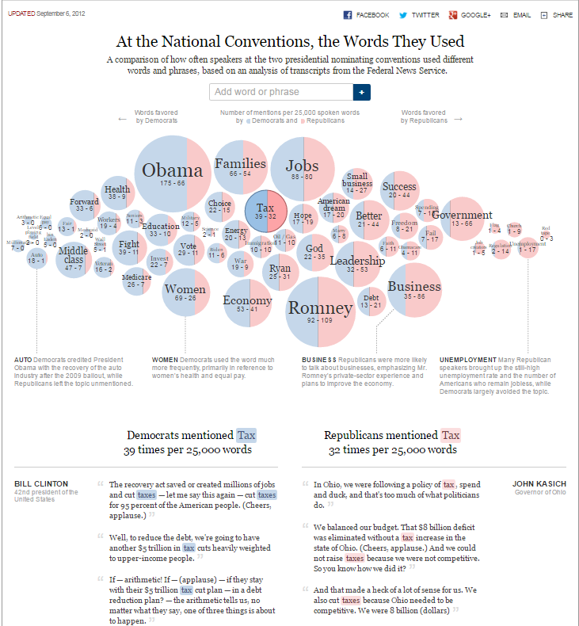

<http://www.nytimes.com/interactive/2012/09/06/us/politics/convention-word-counts.html?_r=0#Tax>

This visualization displays the result of a word frequency analysis of political speeches. The bubble size is proportional to the word frequency and the color filling is split between red for mentions by Republicans and blue for mentions by Democrats. Below are details to show the context in which the words were mentioned.

In our project, we could create a similar visualization where we select two Ukraine regions or two IED event categories and compare the use of words in the details and remarks free text properties of the incidents. This visualization is very effective for making comparisons.